2. Write a C program to simulate a Non-Deterministic Finite Automata

(NFA) for the given language.

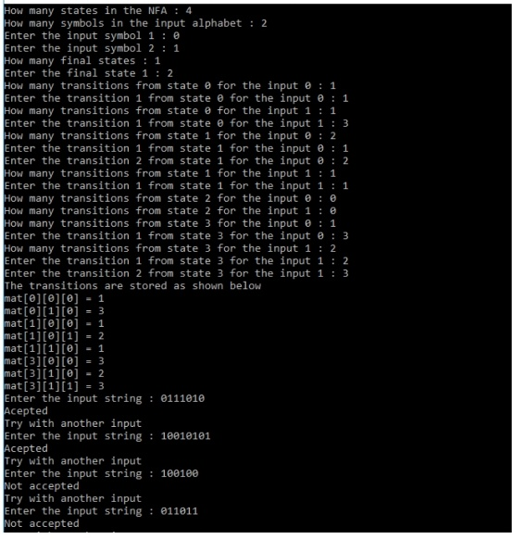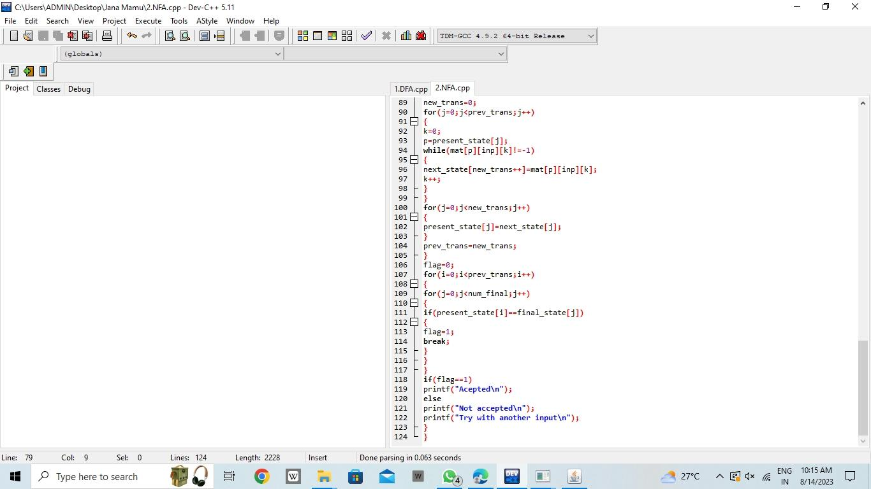

**Result:** Hence, we written C program to simulate a Non-Deterministic Finite Automata

(NFA) for the given language.